Press release

Utrecht, 8 October 2018

Dutch Minister to open ITS Forum 2018
On 14 November 2018 Cora van Nieuwenhuizen, Dutch Minister of Infrastructure and Water Management, will open the bi-annual European conference on traffic management called ITS Forum 2018. She will be accompanied by Federica Polce – Coordinator of the Platform on behalf of the Italian Ministry of Infrastructure and Transport. Rijkswaterstaat officials will interview Matthew Baldwin, Deputy Director-General of EC DG MOVE.

The ITS Forum offers a varied and interesting programme centred around the theme: “Traffic Management in a changing world”. All of this will take place in a highly innovative and dynamic venue - LEF Future Centre in Utrecht. High level keynote speakers from all over Europe will contribute to the programme among whom Herald Ruijters (EC Director Investment, Innovative & Sustainable Transport – DG MOVE) with a keynote on past, present and future perspectives of the European core network, and Pierpaolo Tona (European Commission - Innovation and Networks Executive Agency - INEA) introducing the ITS Programme of the Connecting Europe Facility (CEF). The closing session will see an interview of Isabelle Vandoorne (EC Deputy Head of Unit on Sustainable & Intelligent Transport – DG MOVE) jointly to key experts and high level stakeholders in the field of ITS and mobility (CEDR, IBTTA, FIA, ERF, POLIS).

Traffic management in a changing world
New technologies such as connected, cooperative and automated driving will drastically change the world of traffic management. Traditional ITS (Intelligent Transport Systems) will increasingly be complemented by C-ITS (Connected ITS) and other new technologies, allowing new travel services to emerge, such as Mobility as a Service (MaaS). And with larger cities and more complex, busier networks, different road authorities need to collaborate and work with industry (car manufacturers, ITS industry, content providers) and knowledge partners. In other words, traditional traffic management and roles are changing.

The main theme of Forum “Traffic Management in a changing world - Digitalization, Multimodality, Smart Infrastructures” reflects a number of objectives of the Forum. Digitalization and smart infrastructures will lead to more data, from vehicles and from infrastructure, which will be used to make transport safer and more efficient. Digitalization will also change the way traffic management centres will operate, e.g. by using smart cameras, using data from other (private) sources, using big data. But also by providing individualized route advices, most likely in cooperation with private service providers, using roadside beacons (G5) and telecommunication (4G, 5G).

On the one hand traffic management will benefit from new technologies and trends (e.g. floating car data, on-board systems, AI, …) and on the other hand new technologies (e.g. C-ITS, automated driving, …) will result in new requirements for road operators and new business models. Road operators/authorities will have to handle these changes in their environment, such as a shift from public to private services, systems as a service, from ownership to sharing economy, etc.

The full programme including workshops, plenary and parallel sessions and speakers can be found here: https://www.aanmelder.nl/itsforum2018/session-overview.

Facing challenges together
The 2-day forum plus social event is organized by the EU ITS Platform, in cooperation with the European Commission as well as the European ITS corridor projects Arc Atlantique, Crocodile, MedTIS, Next-ITS and Ursa Major Neo. Within the European ITS Platform European road operators and authorities have teamed up with external stakeholders to foster European harmonisation of ITS and deliver prominent results. The ITS Forum is a bi-annual gathering to discuss these results with each other and other stakeholders.
European colleagues gathered in Utrecht
The forum invites all public and private stakeholders in traffic management:

- Road Authorities/Public Motorway Operators
- Private Motorway Operators
- Urban Road Operators
- ITS System Providers for Traffic Management
- ITS System Providers for Traffic Information
- Traffic Information Service Providers
- Representatives of the automotive Industry
- Experts in C-ITS Development
- International Stakeholder Organisations (not covered by the domains above)
- Consultants
- Researchers

Special venue: LEF Future Center
LEF Future Center at the Rijkswaterstaat office in Utrecht is specialised in fostering new patterns of thought and forcing breakthroughs. LEF offers a wide variety of diverse working environments and professional guidance. Participants of the ITS Forum 2018 will experience the advantages of LEF’s innovative settings which guarantees a high level of interaction and brings new ideas and insights.

More information
Please visit our website www.itsforum2018.eu for more information about the programme, the European ITS Platform and the venue of the event.

----------------------------------------------End of press release----------------------------------------------------

Note for the editor
For further information please contact:
Kjersti Leiren Boag, Statens vegvesen Vegdirektoratet
Phone: +4799596174
E-mail: kjersti.boag@vegvesen.no

If you are interested to participate in the event as a journalist, please contact Esther de Waard (esther@dnamic.nl). Participation for the press is free of charge.

About the European ITS Platform
The EU ITS Platform brings together the key European players cooperating to establish an open forum which provides a joint contribution to future strategy and contributes to the policy recommendations for the improved development and deployment of ITS services along European Road Corridors. Authorities and operators are working together in the European ITS platform towards a smarter and more efficient mobility, a goal which will be achieved through large-scale technology deployments. The EU ITS Platform is partly funded by the Connecting Europe Facility of the European Commission.

Annex:
Annex 1: Logo of the ITS Forum 2018
Annex 2: Picture of Dutch Minister Cora van Nieuwenhuizen
Annex 3: Draft programme

Annex 1: logo of the ITS Forum 2018

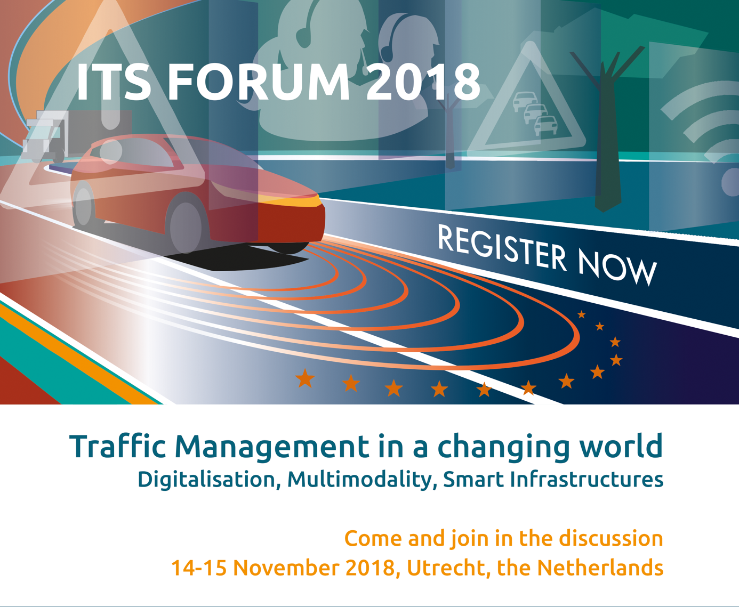

Annex 2: Picture of Dutch Minister
See also: https://www.government.nl/government/members-of-cabinet/cora-van-nieuwenhuizen

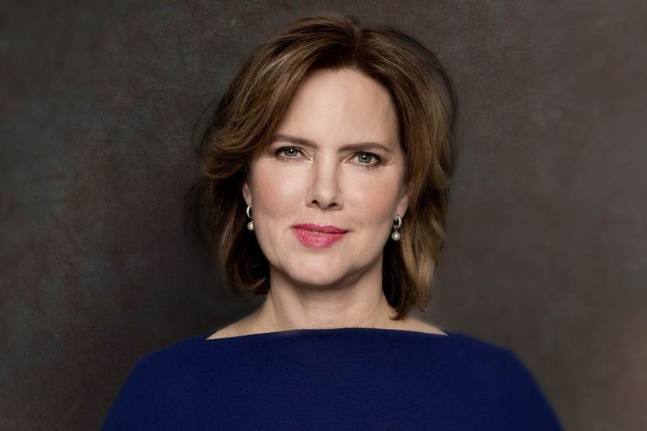
Annex 3: draft programme
